Introduction and Stress Strain Relation:
Introduction of Composite Material:
A composite is a structural material that consists of two or more combined constituents that are combined at a macroscopic level and are not soluble in each other
Reinforcing phase: fibers, particles, or flakes.
Matrix phase: polymers, metals, ceramics.
Composites are becoming an essential part of today’s materials because they offer advantages such as low weight, corrosion resistance, high fatigue strength, faster assembly, etc. Composites are used as materials in making aircraft structures to golf clubs, electronic packaging to medical equipment, and space vehicles to home building. Composites are generating curiosity and interest in students all over the world. They are seeing everyday applications of composite materials in the commercial market, and job opportunities are increasing in this field. The technology transfer initiative of the US federal government is opening new and large scale opportunities for use of advanced composite materials.
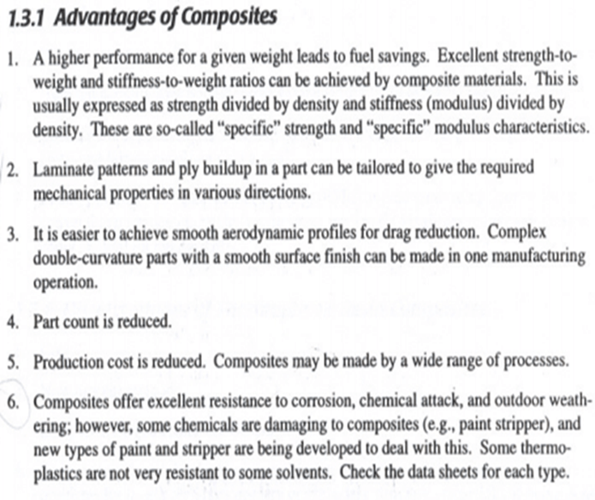
Applications:

Each year, composites find their way into hundreds of new applications, from golf clubs and tennis rackets to jet skis, aircraft, missiles and spacecraft. Composite materials offer designers an increasing array of as a material and system solution. At the same time, composite cost trends are highly favorable, especially when the total cost of fabrication is considered. Processes such as pultrusion offer the means to convert composite materials into finished products in a single trip through the machinery. Composite sheet moulding compounds allow the formation of complete automobile skin panels in a single stroke of a press.
Advantages
Composites offer many advantages over other materials. The main advantages of composites may be summarized as:
- Stronger and stiffer than metals on a density basis
  - For the same strength, lighter than steel by 80% and aluminium by 60%
  - Superior stiffness-to-weight ratios
- Capable of high continuous operating temperatures
  - Up to 250°F in many composites
  - Up to 2000°F with specialist composites
- Highly corrosion resistant
  - Essentially inert in the most corrosive environments
- Electrically insulating properties are inherent in most composites (depending on reinforcement selected).
  - Yet composites can be made conducting or selectively conducting as needed.
- Tolerable thermal expansion properties
  - Can be compounded to closely match surrounding structures to minimize thermal stresses
- Tunable energy management characteristics
  - High energy absorption or high energy conductivity at designer’s choice
  - Frequency selective acoustical and electromagnetic energy passage
- Exceptional formability
  - Composites can be formed into many complex shapes during fabrication, even providing finished, styled surfaces in the process.
- Outstanding durability
  - Well-designed composites have exhibited apparent infinite life characteristics, even in extremely harsh environments
- Low investment in fabrication equipment
  - The inherent characteristics of composites typically allow production to be established for a small fraction of the cost that would be required in metallic fabrication.
- Reduced Part Counts
  - Parts that were formerly assembled out of several smaller metallic components can be fabricated into a larger single part. This reduces manufacturing and assembly labour and time.
- Corrosion Resistance
  - The non-reactive nature of many resins and reinforcements can be custom selected to resist degradation by many common materials and in corrosive environments.
  - Benefits include lower maintenance and replacement costs.
- Electromagnetic properties
  - Radar works by sending out directional radio waves (electromagnetic radiation) through the air, then listening for a reflected return from an airplane or other object. Composites are normally transparent to electromagnetic radiation, but can be “seeded” with appropriate materials to absorb such radiation and divert its energy away from the source. This low observability is called “stealth” in the popular press, and is a vitally important capability in military applications.
  - Composite materials can also be used to reduce transmitted mechanical noise from a ship or submarine to the surrounding water, thus making it more difficult to detect vessels using acoustic means.

Reinforcement and Matrices:
Fibres are particularly attractive as reinforcement because
Spinning imparts strength and stiffness to them
· Their small diameter (usually 7 to about 20 µm) implies a low probability of defects and allows a higher fraction of ideal strength to be attained (strength decreases with increasing diameter); this having a positive influence on mechanical properties of fibres
· They are flexible and thus can undergo bending with a radius of curvature, r_{min} = 0.1 to 1 mm, without breaking (proceed from the simple theory of bending
where fibres are necessarily handled and should not break, and also for flexible composites like tyres.
A single fibre is often referred to as a filament. Several hundreds or thousands of filaments (count) can be put together to form so called strands, rovings, yarns or tows. So called heavy
tows containing several tens of thousands (for example 100 k) of filaments have been introduced more recently.
Towards their high performance in composites, fibres are coated with sizing which
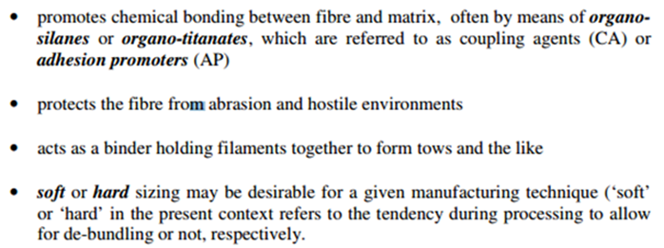
Generalized Hook’s Law
Stress-Strain Relation:
The generalized Hooke’s Law can be used to predict the deformations caused in a given material by an arbitrary combination of stresses.
The linear relationship between stress and strain applies for 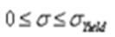
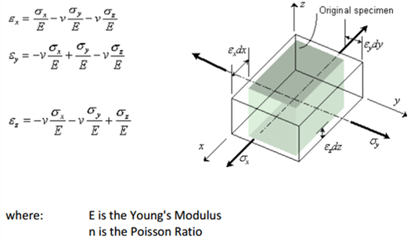
The generalized Hooke’s Law also reveals that strain can exist without stress. For example, if the member is experiencing a load in the y-direction (which in turn causes a stress in the y-direction), the Hooke’s Law shows that strain in the x-direction does not equal to zero. This is because as material is being pulled outward by the y-plane, the material in the x-plane moves inward to fill in the space once occupied, just like an elastic band becomes thinner as you try to pull it apart. In this situation, the x-plane does not have any external force acting on them but they experience a change in length.
Therefore, it is valid to say that strain exist without stress in the x-plane.
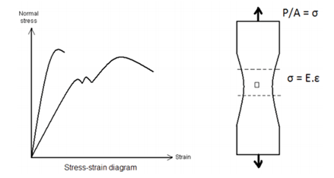
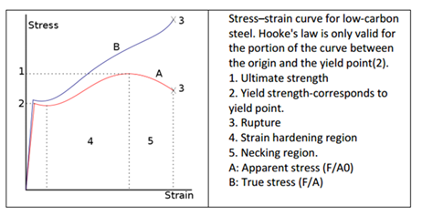
We need to connect all six components of stress to six components of strain.
– Restrict to linearly elastic-small strains.
– An isotropic materials whose properties are independent of orientation.
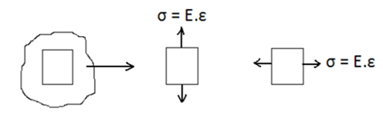
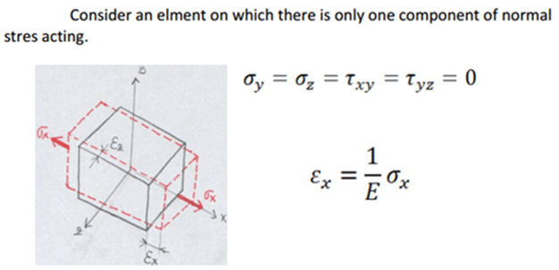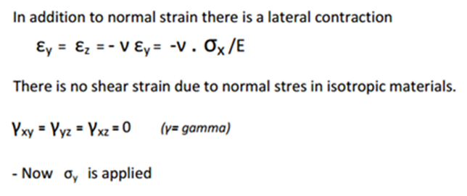
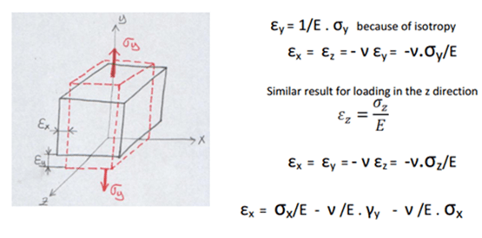
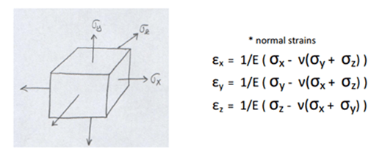
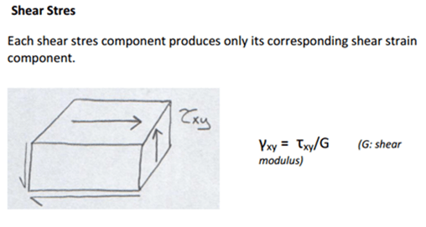
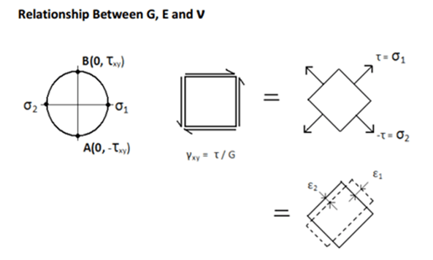
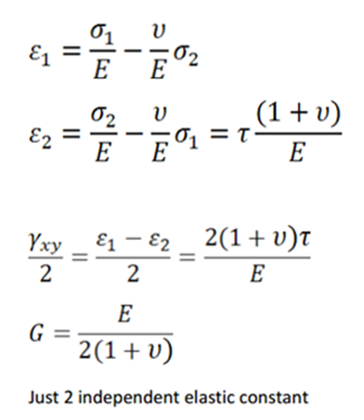
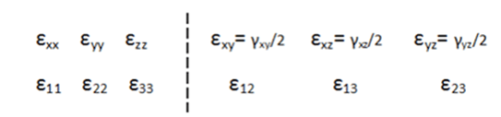
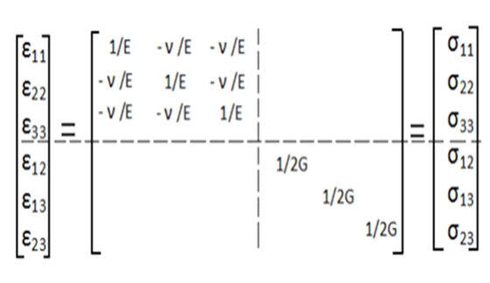

Elastic constants for anisotropic orthotropic and isotropic materials:
Some engineering materials, including certain piezoelectric materials (e.g. Rochelle salt) and 2-ply fiber-reinforced composites, are orthotropic.
By definition, an orthotropic material has at least 2 orthogonal planes of symmetry, where material properties are independent of direction within each plane. Such materials require 9 independent variables (i.e. elastic constants) in their constitutive matrices.
In contrast, a material without any planes of symmetry is fully anisotropic and requires 21 elastic constants, whereas a material with an infinite number of symmetry planes (i.e. every plane is a plane of symmetry) is isotropic, and requires only 2 elastic constants.
THREE-DIMENSIONAL MATERIAL ANISOTROPY:
For a three-dimensional elastic anisotropic body (Fig. 6.1), the generalized Hook’s law is expressed as
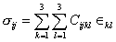 (i, j = 1,2,3) (6.1)
where and are the stress and strain tensors, respectively, and are the elastic constants. Here the indices i, j, k and l can assume values of 1, 2 and 3. This implies that there may exist 3⁴ = 81 independent elastic constants. However, it is known from the theory of elasticity, that both stress tensor and strain tensor are symmetric. As = , =
and as = , = (6.2)
Thus, = = = (6.3)
This results in reduction of possible independent elastic constants to thirty-six.
Further, if there exists a strain energy U such that
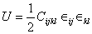
with the property that 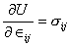, then
= (6.5)
Equation 6.5 in conjunction with Eq. 6.3 finally reduce the total number of independent elastic constants from thirty-six to twenty-one only. Such an anisotropic material with twenty-one independent elastic constants is termed as triclinic. Now, using the following contracted single index notations
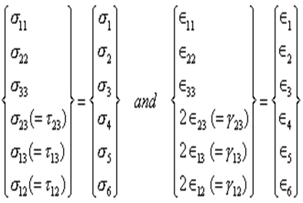
the constitutive relations for the general case of material anisotropy are expressed as

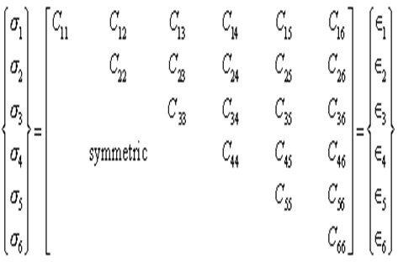
or, ; i, j = 1, 2,6 (6.8)
Here, [ ] is the elastic constant matrix.
Conversely, { } = [S_{ij} ] { } ; i, j =1, 2,6 (6.9)
where [S_{ij}] is the compliance matrix.
Note that
[S_{ij}] = [C_{ij} ]⁻¹ (6.10)
Also, [ ] =[ ] and [S_{ij}] = [S_{ji}] due to symmetry.
MATERIAL SYMMETRY:
There may exist several situations when the distribution and orientation of reinforcements may give rise to special cases of material property symmetry. When there is one plane of material property symmetry (say, the plane of symmetry is x₃ ₌ 0, i.e., the rotation of 180 degree around the x3 axis yields an equivalent material), the elastic constant matrix [ ] is modified as
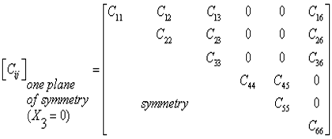 (6.11)
Thus there are thirteen independent elastic constants, and the material is monoclinic. The compliance matrix [S_{ij}] for a monoclinic material may accordingly be written from Eq. 6.11 by replacing ‘C ‘ with ‘S ‘.
If there are three mutually orthogonal planes of symmetry, the material behaviour is orthotropic. The elastic constant matrix is then expressed as
_{orthotropic} = 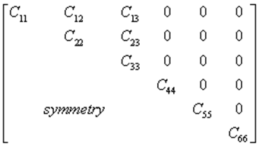 (6.12)
Thus there are nine independent elastic constants. Correspondingly there exist nine independent compliances.
Two special cases of symmetry, square symmetry and hexagonal symmetry, may arise due to packing of fibres in some regular fashion. This results in further reduction of independent elastic constant. For instance, if the fibres are packed in a square array (Fig. 6.2) in the X_{2,} X₃ plane. Then [ ]
_{square array} = 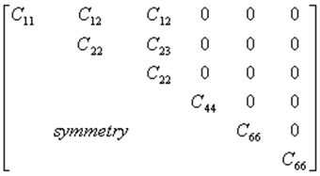 (6.13)
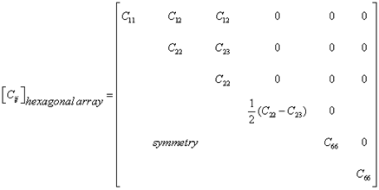 (6.14)
In the case of hexagonal symmetry, the number of independent elastic constants is reduced to five only. The material symmetry equivalent to the hexagonal symmetry, is also achieved, if the fibres are packed in a random fashion (Fig. 6.4) in the X₂X₃ plane. This form of symmetry is usually termed as transverse isotropy. The [ ] matrix due to the transverse isotropy is the same as that given in Eq. 6.14. The compliance matrices corresponding to Eqs. 6.12 through 6.14 can be accordingly written down. However, it may be noted that in the case of rectangular array (Fig. 6.5), C₁₂ ≠ C₁₃, C₂₂ ≠ C₃₃ and C₅₅ ≠ C₆₆ (Eq. 6.13).
Material Isotropy
The material properties remain independent of directional change for an isotropic material. The elastic constant matrix [ ] for a three dimensional isotropic material are expressed as
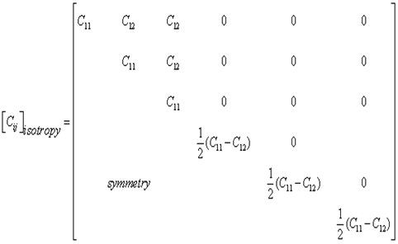 (6.15)
The compliance matrix [S_{ij}] for an isotropic material can be accordingly derived.

